EXP:1 Implement and demonstrate the FIND-S algorithm for finding the most specific hypothesis based on a given set of training data samples.

Aim:
To implement and demonstrate the FIND-S Algorithm for finding the most specific hypothesis that is consistent with the given training examples.

Algorithm Steps:
- Initialize the hypothesis as the most specific hypothesis.
- For each positive training example:
  - Compare it with the current hypothesis.
  - If an attribute differs, replace it with '?'.
- Ignore all negative training examples.
- Output the final hypothesis.
Program:
# Import the pandas library
import pandas as pd

# Create the training dataset
training_data = {
"Sky": ["Sunny", "Sunny", "Rainy", "Sunny"],
"AirTemp": ["Warm", "Warm", "Cold", "Warm"],
"Humidity": ["Normal", "High", "High", "High"],
"Wind": ["Strong", "Strong", "Strong", "Strong"],
"Water": ["Warm", "Warm", "Warm", "Cool"],
"Forecast": ["Same", "Same", "Change", "Same"],
"EnjoySport": ["Yes", "Yes", "No", "Yes"]
}

# Convert dictionary into DataFrame
dataset = pd.DataFrame(training_data)

# Display the dataset
print("Training Data:\n")
print(dataset)

# Separate attributes and target class
attributes = dataset.iloc[:, :-1].values
labels = dataset.iloc[:, -1].values

# Function to implement Find-S Algorithm
def find_specific_hypothesis(attributes, labels):

hypothesis = None

for sample, output in zip(attributes, labels):

if output == "Yes":

if hypothesis is None:
hypothesis = sample.copy()
else:
for index in range(len(hypothesis)):
if hypothesis[index] != sample[index]:
hypothesis[index] = "?"

return hypothesis

# Generate the final hypothesis
result = find_specific_hypothesis(attributes, labels)

# Display the result
print("\nMost Specific Hypothesis:")
print(result)
Output:

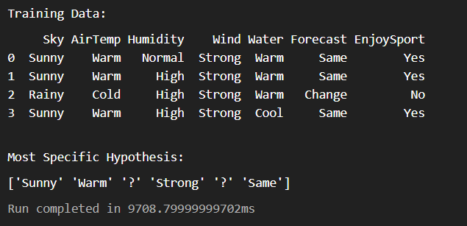

Result:
The FIND-S algorithm was successfully implemented using Python.

